**Person_Beer_Preference**

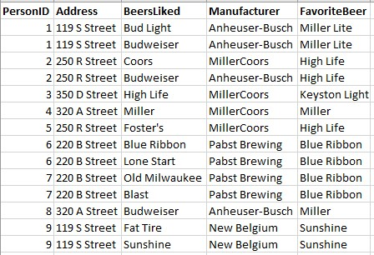

There are several functional dependencies in the table. Two of them are given below. Find and write down another functional dependency. Then, based on all the functional dependencies, write down the normalized tables using the Relation Expressions:

**Functional Dependencies**

(PersonID, BeersLiked) ->Address, Manufacturer, FavoriteBeer

PersonID -> Address, FavoriteBeer

BeersLiked 🡪 Manufacturer

**Normalized tables:**

tblPerson(PersonID, Address, BeerLikedID, Favorite Beer)

tblBeersLiked(BeersLikedID, BeersLiked, Manufacturer)

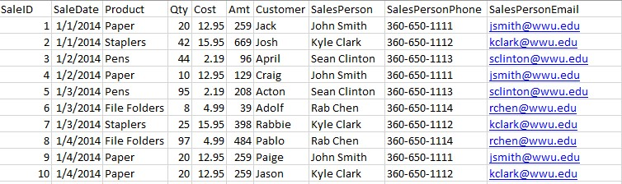

Two functional dependencies are given. Find and write down another functional dependency (Hint: two columns are determined by another column). Then, based on all the functional dependencies, write down the normalized tables using the Relation Expressions:

**Functional Dependencies:**

SaleID → SaleDate, Product, Qty, Cost, Amt, Customer, SalesPerson, SalesPersonPhone, SalesPersonEmail

Product -> Cost

SalesPerson 🡪 SalesPersonPhone, SalesPersonEmail

**Normalized tables:**

tblSalesPerson (SalesPersonID, SalesPersonPhone, SalesPersonEmail)

tblProduct(ProductID, Product Cost)

tblSale(SaleID, SaleDate, ProductID, Qty, Amt, SalesPersonID)

**Submit this file to Canvas!**